**Airport data Analysis**

* **No. of Flights by day**

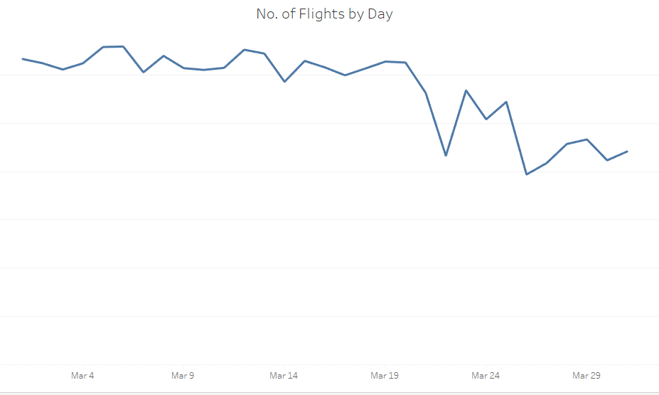

* **Top 5 Most No. of Flights from San Francisco**

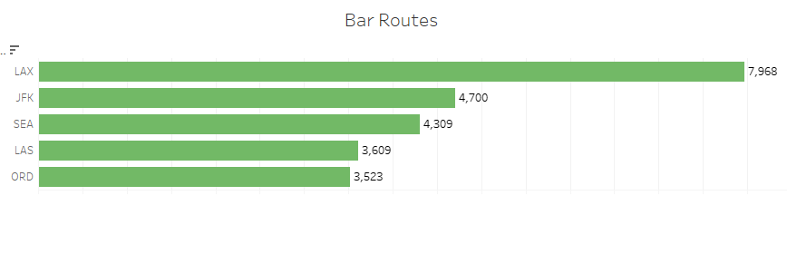

* **5 Long Distance from San Francisco**

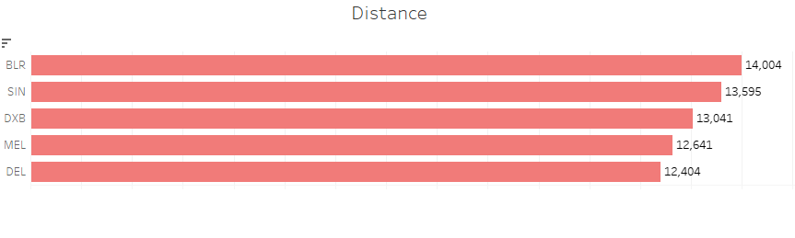

**Dashboard**

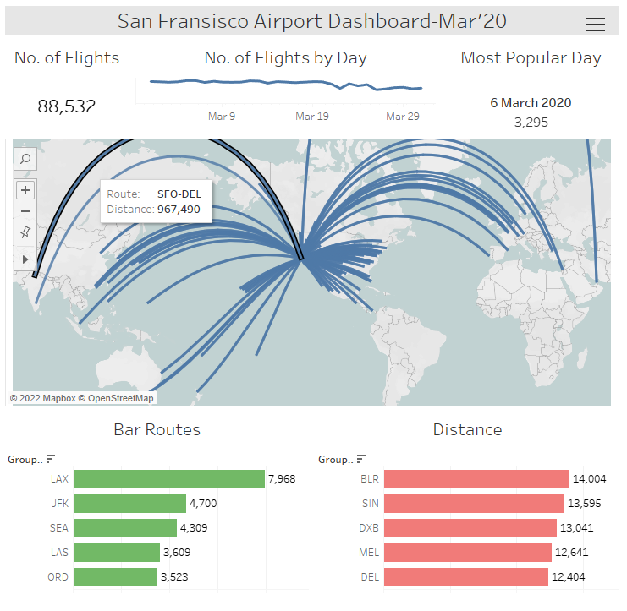

**Key Insights**

1. Total No. of flights from San Francisco in March Month is **88,532**
2. Trend line shows that in March month during end of months the travellers get less.
3. Most popular Day of Flight is **6 March**
4. Most Common route is LAX
5. Longest Distance from San Francisco is **Banglore**

[Project Link](https://public.tableau.com/app/profile/pankaj.kumar8375/viz/Project_16566927728680/Dashboard1?publish=yes)